DAY 3 TEST

11. Count the Number of Vowels and Consonants in a Sentence

**Program:**

**// Count the Number of Vowels and Consonants in a Sentence**

#include <stdio.h>

void main()

{

char string[50];

int x, vow = 0, cons = 0, special = 0;

printf("Enter The String : \n");

gets(string);

for (x = 0; string[x] != '\0'; x++)

{

if ((string[x] == 'a' || string[x] == 'e' || string[x] ==

'i' || string[x] == 'o' || string[x] == 'u') ||

(string[x] == 'A' || string[x] == 'E' || string[x] ==

'I' || string[x] == 'O' || string[x] == 'U'))

{

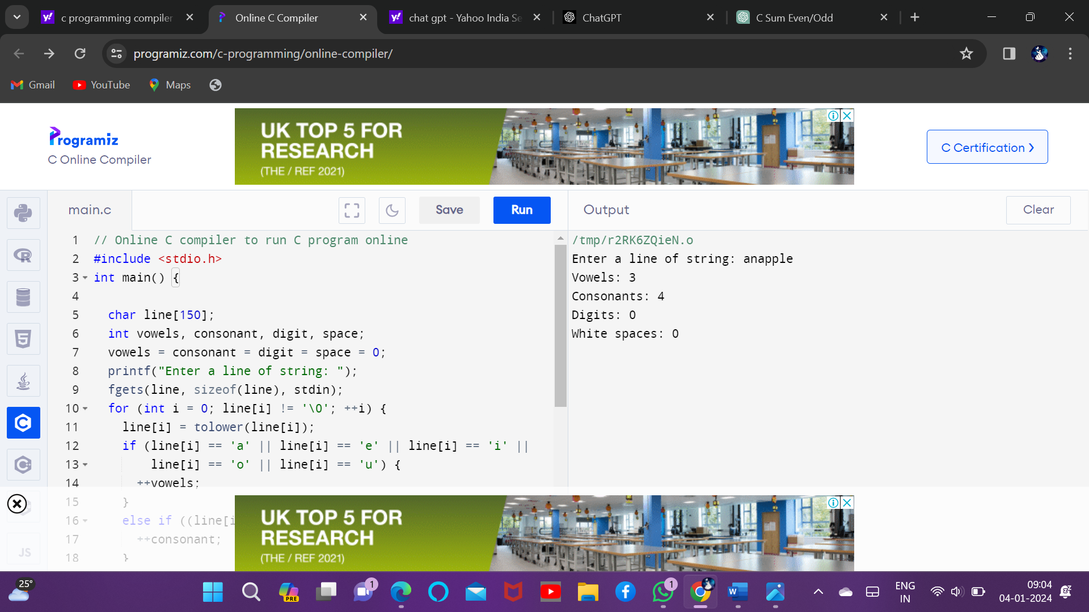

vow = vow + 1;

}

else

{

cons = cons + 1;

}

if (string[x] =='\t' ||string[x] =='\0' || string[x] ==' ')

{

special = special + 1;

}

}

cons = cons - special;

printf("Number Of Vowels In The Given String Is %s = %d\n", string, vow);

printf("Number Of Consonants In The Given String Is %s = %d\n", string, cons);

}

12. Accept the Height of a Person & Categorize as Taller, Dwarf & Average

**Program:**

**// Accept the Height of a Person & Categorize as Taller, Dwarf & Average**

#include <stdio.h>

void main()

{

float height;

printf("Enter the Height (in centimetres) \n");

scanf("%f", &height);

if (height < 150.0)

printf("Dwarf \n");

else if ((height >= 150.0) && (height <= 165.0))

printf(" Average Height \n");

else if ((height > 165.0) && (height <= 195.0))

printf("Taller \n");

else

printf("Abnormal height \n");

}

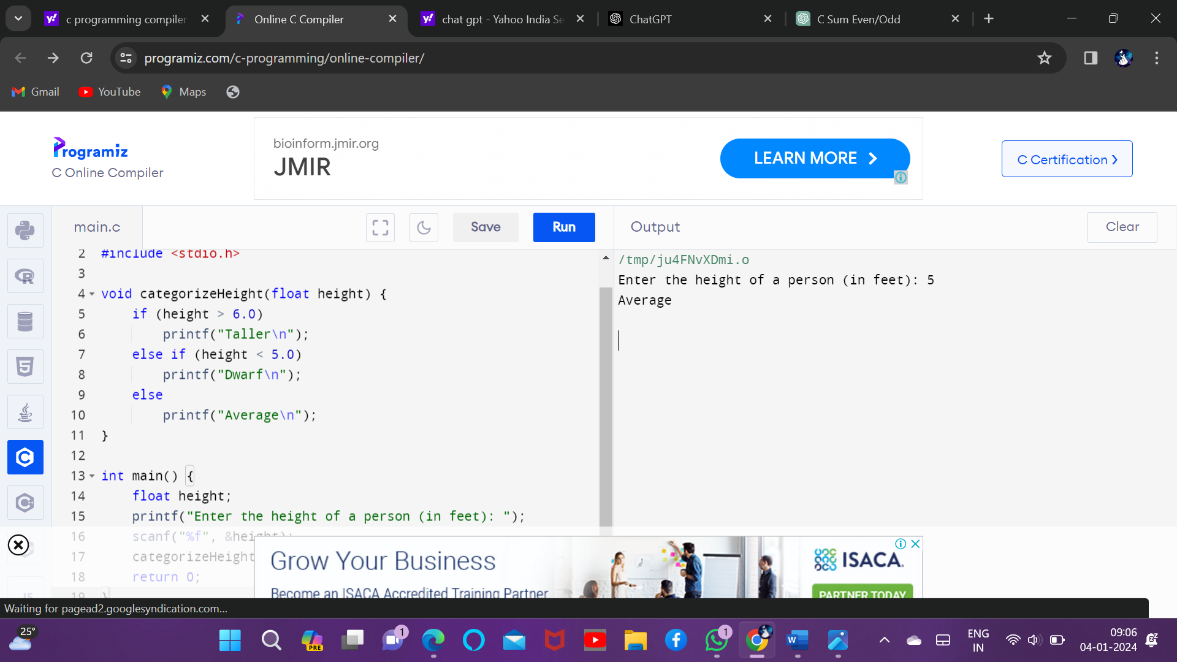

13. Prime Number

**Program:**

// Prime Number

#include <stdio.h>

main() {

int n, i, c = 0;

printf("Enter any number n:");

scanf("%d", &n);

//logic

for (i = 1; i <= n; i++) {

if (n % i == 0) {

c++;

}

}

if (c == 2) {

printf("%d is a Prime number", n);

}

else {

printf("%d is not a Prime number", n);

}

return 0;

}

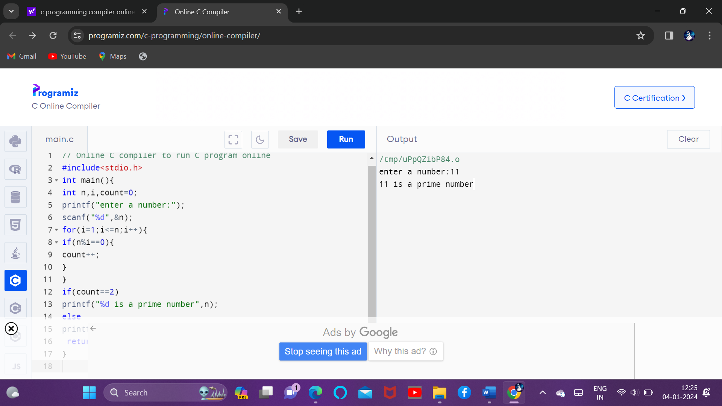

14. Check Whether a Given Number is Perfect Number

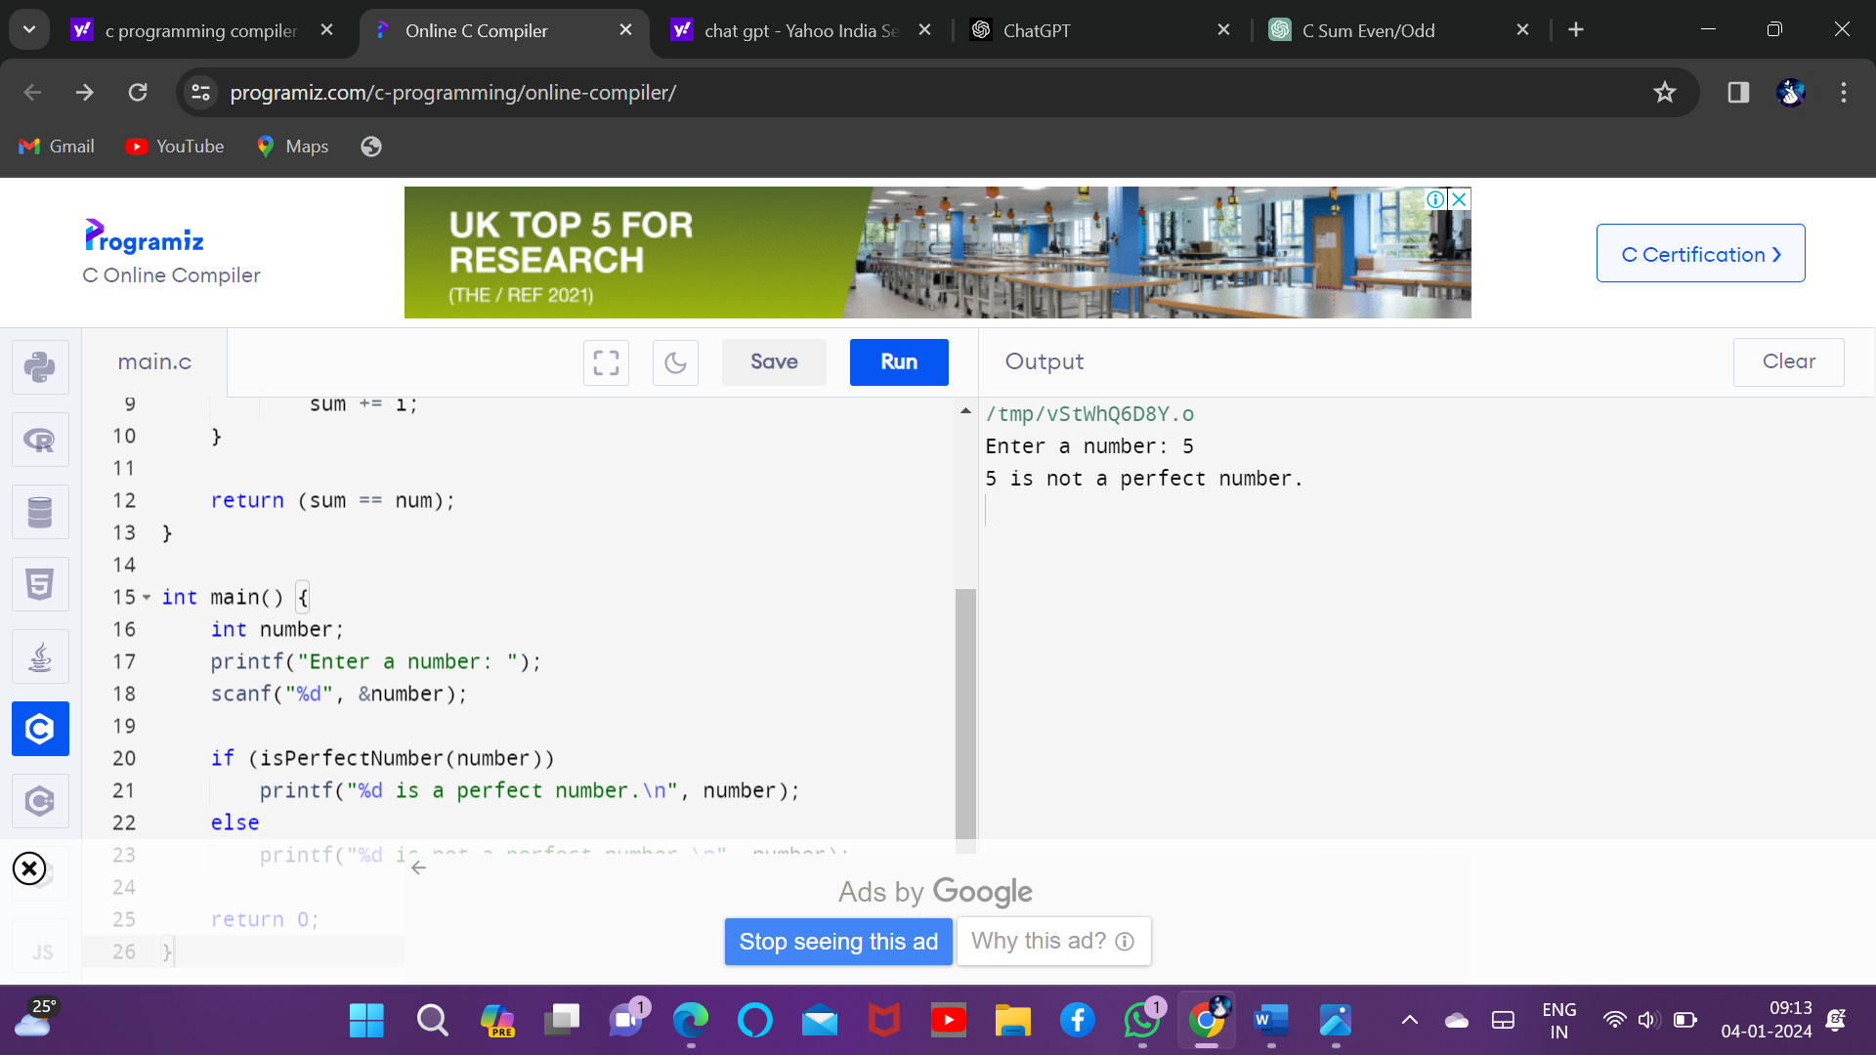

**Program:**

// Check Whether a Given Number is Perfect Number

#include <stdio.h>

int main()

{

int number, rem, sum = 0, i;

printf("Enter a Number: ");

scanf("%d", &number);

for (i = 1; i <= (number - 1); i++)

{

rem = number % i;

if (rem == 0)

{

sum = sum + i;

}

}

if (sum == number)

printf("%d is perfect number", number);

else

printf("%d is not a perfect number", number);

return 0;

}

15. Check Armstrong Number

